**Advanced Programming Assignment - Employee Database  
Elliot Lewis - 15083802**

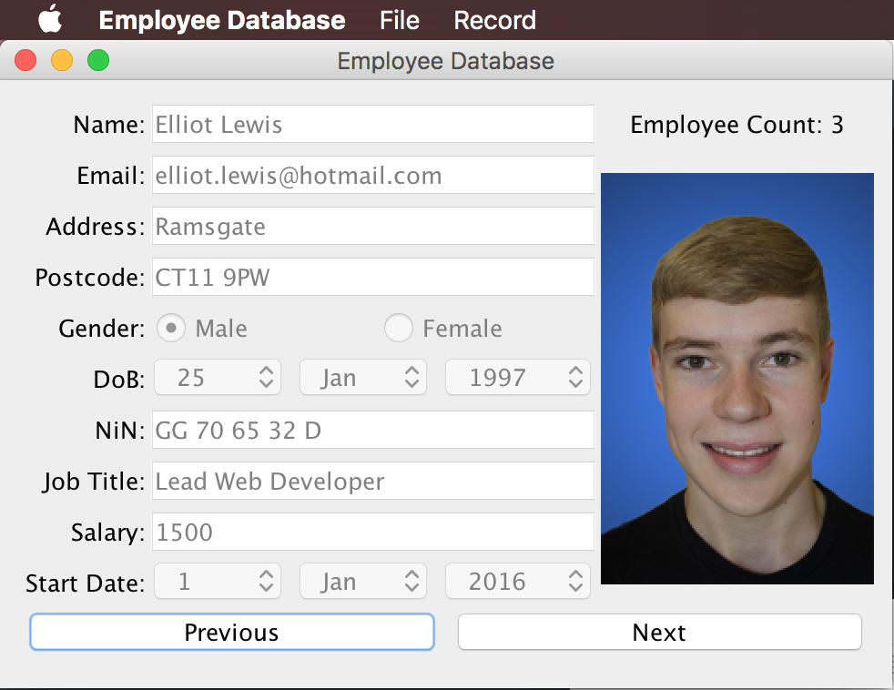

This is the main page of the application; it is loaded when the application is run. It has 2 buttons, previous and next, which allow the user to navigate through the employees in the system. When the next button is pressed, the employee details of the next employee are loaded in.

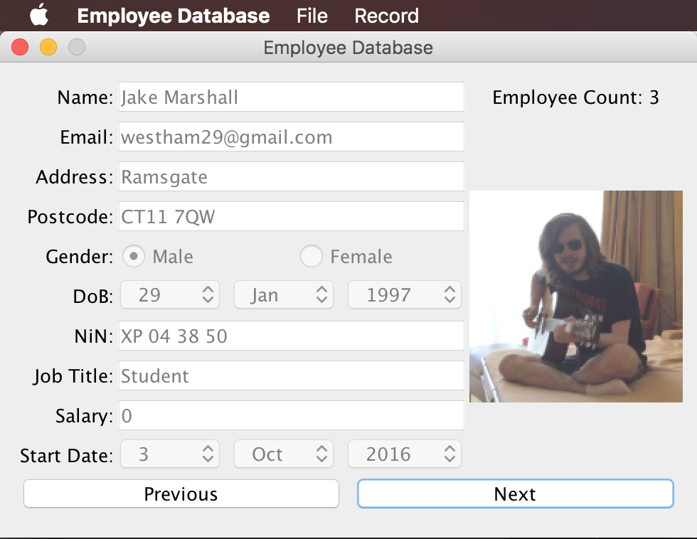

Here, you can see that the name, email, address, postcode, gender, dob, national insurance number, job title, salary, start date, and image have all updated to represent the next employee. At the top of the screen, you can see in the mac menu bar that there is a file menu and a record menu.

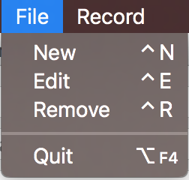 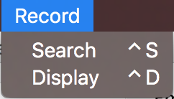

As you can see, there are various options on each, the file menu has new, edit, remove and quit. The edit option sets the GUI into edit mode as shown below, and allows the user to edit an employee record.

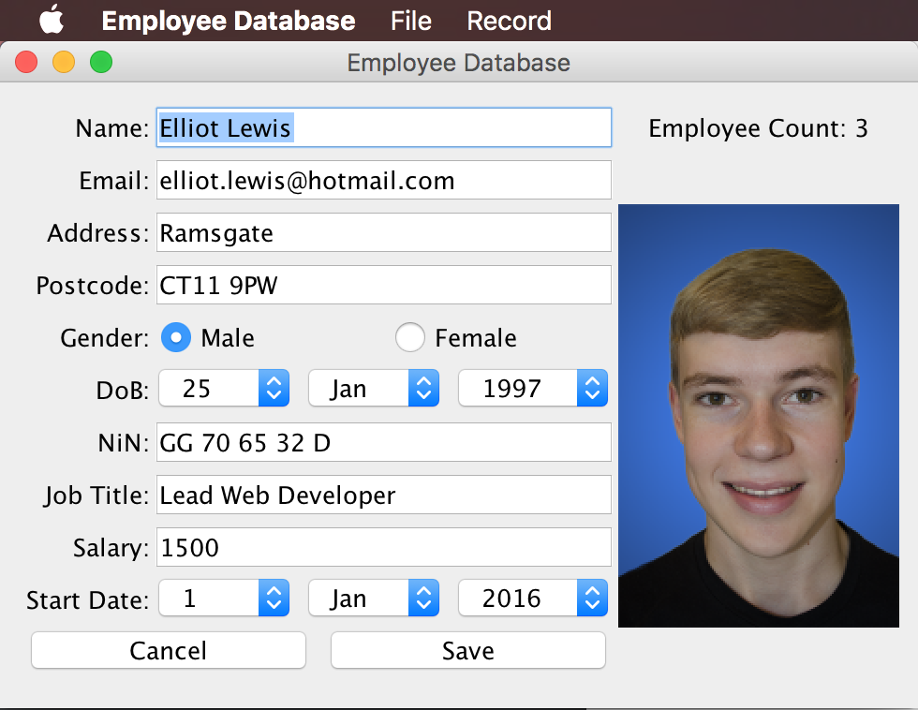

If you click new, then the GUI switches to a blank edit screen with none of the fields filled in, this is shown below.

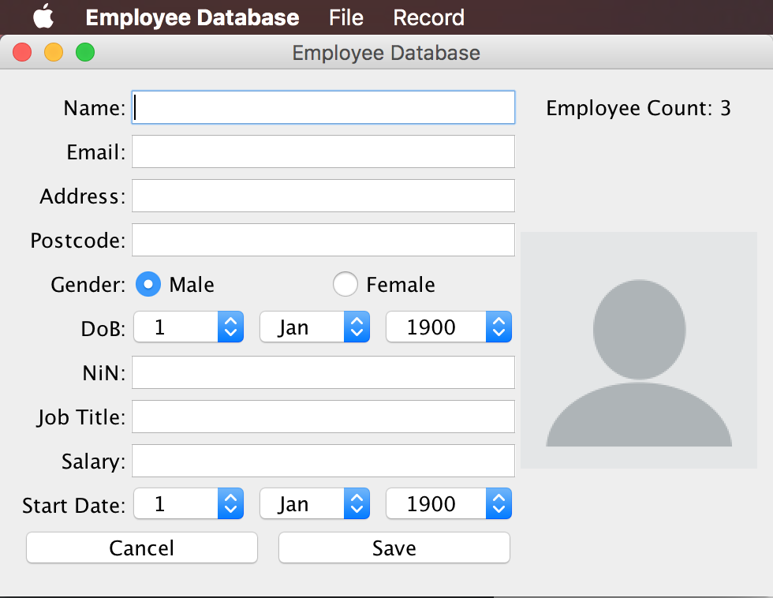

Most of these fields are trivial to edit and adjust, but at first the image may not be obvious, simply click on the image and a file dialog pops up allowing the user to select a new image, a demo of this is shown below.

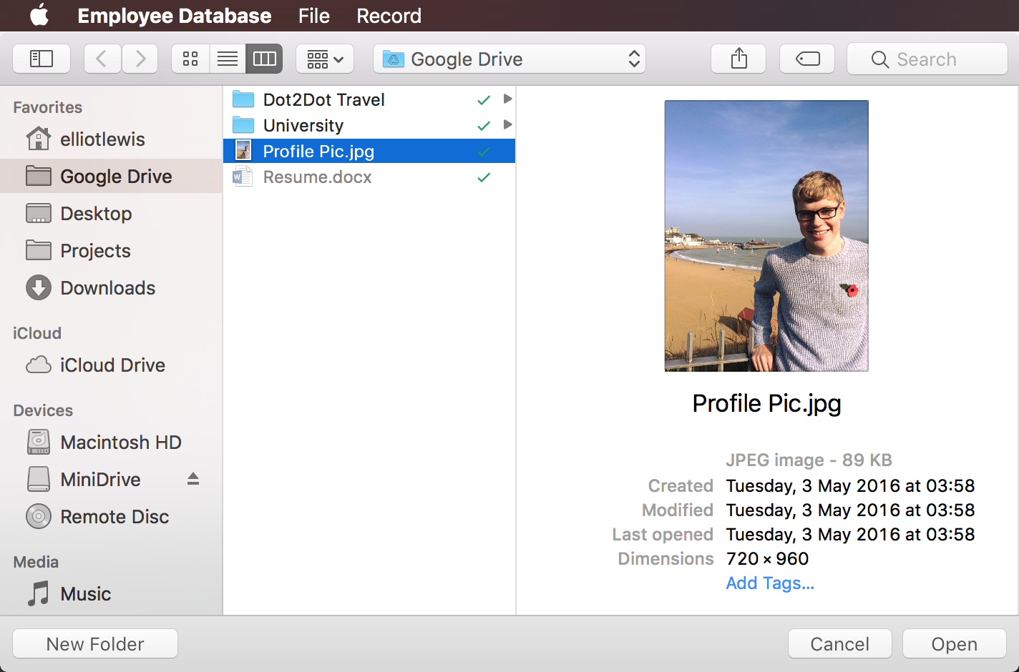 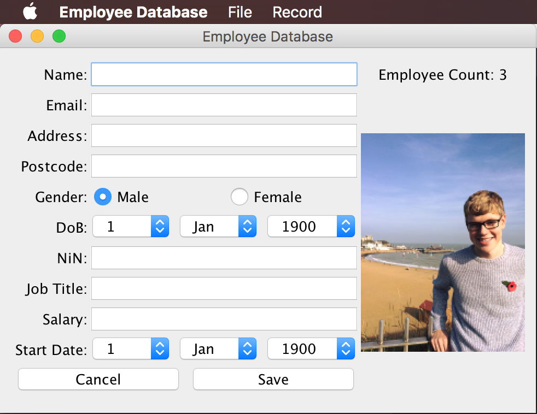

The record menu has a couple of options; the display option simply displays the first employee onto the GUI whilst the search option launches the search GUI. This is shown below.

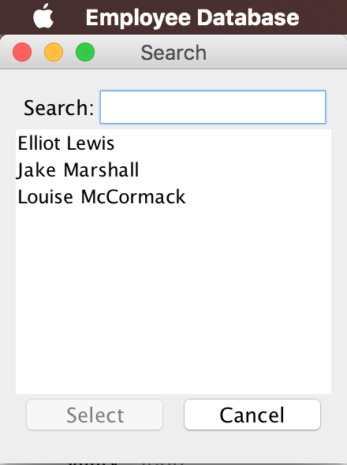

As you start typing in the search box, the results auto narrow down to correlate with the search query. For example, if I type “ell” in the box, the only result will be “Elliot Lewis”. I can then click on that and then click select and the search GUI will close and the main GUI will display the selected record. This process is shown below.

